Mini-Racer

The Mini-Racer is a mini game that should look and feel like a miniature version of the main game in many respects. It should be viewed as a toy rather than a stand alone game. It is a bonus. It is important that its development does not hinder the main game. It should enhance the product and its quality should not detract from the main game. While it should have a positive affect on reviews, it is not a game mode and should not be presented as such. We do not want the mini-game to be reviewed as a major feature. It should increase the overall value and depth of the title and be seen as icing on the cake.

Purpose

- Basic but unlimited replay value
- Give the customer a reason to keep the game once complete
- Ability to pickup and play for 10 minute sessions
- Party game utility with up to four player element
- Further utilize and reuse our most important asset—the dialog
- Further use of the many vehicles in game
- Add additional motivation to collect cards and cars in the main game
- A decent reward for collecting all cards in a level (see below)

Structure

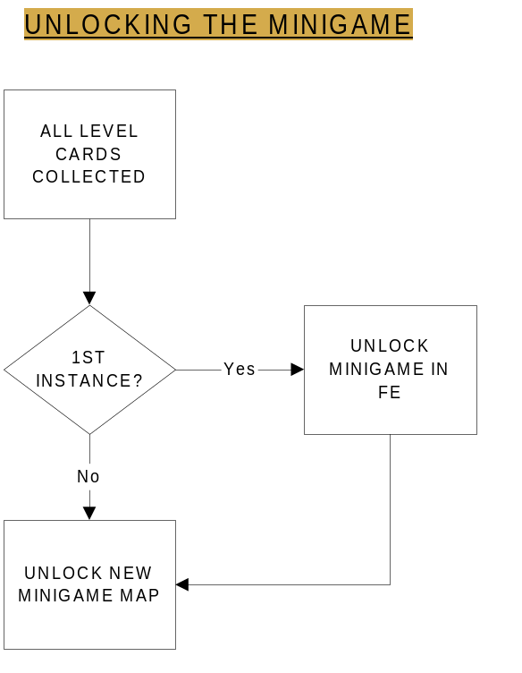
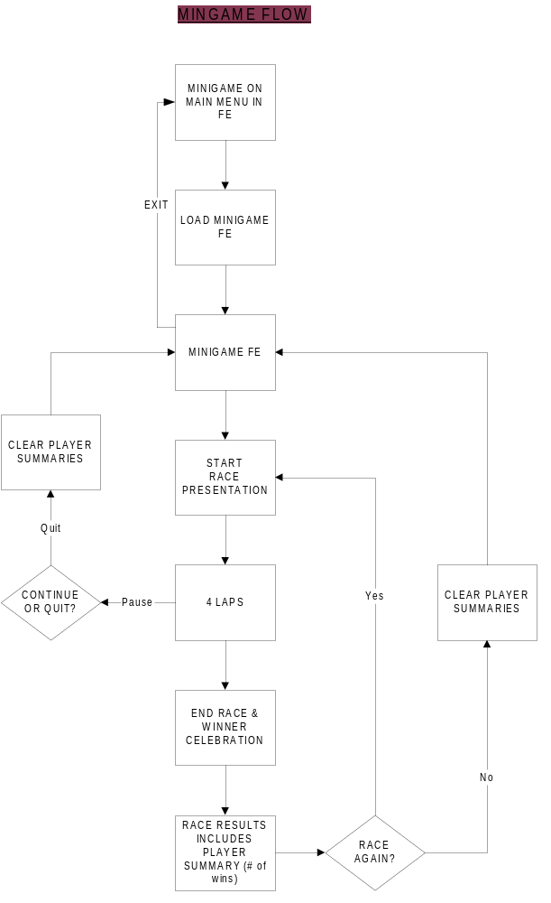

- Once the player collects 7 cards in any level, they will unlock a race track to play on.
  - When this occurs for the first time, a mini toy race track will be displayed in the bottom right corner of the frontend screen from that point onwards.
  - An additional menu selection called “Bonus Game” will be available.
    - Highlighting the “Bonus Game” option highlights the mini race track.
      - Selecting “Bonus Game” triggers a camera path to the race track that transitions to a loading screen for the mini game.
- The Main front end is dumped from memory and the mini game FE screen loads. It is a simple 2D screen that lets the user toggle the following:
  - Unlocked race tracks (one of seven)
  - Purchased and main character driver vehicles from the main game
  - Choose character (one from the five main walkables)
  - Unlocked licensed music tracks (one of seven)(optional: Can tie to level if required)
- The settings for sound and controller vibration from the main menu will carry through to the mini game. There will be NO settings for these options in the mini game FE.
- The game will support up to four human players. If less than 4 human players choose to play, the remaining players will be computer AI controlled. There will always be 4 cars on screen and in play. The AI controlled characters and cars will be randomly chosen from the remaining characters and from the entire unlocked car list. NOTE: this requires support for multi-tap on PS2.
- If game logic will poll for controllers. The game will not allow the race button to be selected until the following conditions are met:
  - Character and car have been selected for each attached controller or one set of controller selections have been made and the timer expires.
  - Once each attached controlled has been locked in to a selection, the race button will be enabled.
  - If a controller is unplugged, it will then become AI controller unless a controller is then attached again—if so, the race button is disabled again until a selection has been locked in or the timer expires.
  - Once one character has selected both character and car, a timer begins to countdown from 15 seconds to speed the other player’s choices along. When the timer expires, the game will automatically load the currently highlighted or confirmed choices and start the race.
- By pressing the BACK button, each controller can back out of their choices. If all controllers back out to the track selection, the next occurrence of BACK will exit to the main menu.
- Default map (optional: and song) will be used unless overridden by choice. By pressing the SELECT button twice on a track, it toggles the direction of the race on that track. This will allow for each map to be used two different ways for very little cost.
- Each character is unique and can only selected by one player
  - When selected, player’s controller number and player color appears above selected character. The choice is locked in, moving their control to the car selection menu unless they press BACK to cancel their selection.
  - Characters are assigned to players on a first to choose/select basis.
- The cars are not unique and can be selected by multiple players. The cars will be differentiated by shadow color that corresponds to the player’s color.
- The mini game FE stays resident in memory until exited to the main frontend menu. This will allow for multiple mini game sessions where maps, characters and cars can be selected without exiting to the memory intensive main menu. It also means that the main menu will not require additional frontend art to be loaded by default.
- When the “Race” button is selected, the correct map, cars and characters are loaded into memory for the gameplay session.
- The game session will start with a close up 3D view of the characters and cars for presentation purposes.
- A game will last for 4 laps. The winner is the first to complete these laps. See below for a detailed view of gameplay.
- Each player is awarded points for the position that they finished in.
- When the first player finishes, a clock will begin to countdown. Those that do no finish in time are DNF—no points are rewarded for not finishing.
- The race will end with a 3D close up with the winner doing a celebration animation—this can be the same animation for a card “Get.”
- The game will then transition to a screen summarizing race placement and current score that shows the following:
  - Placement in current race results for each player
  - Running total for consecutive races for each player ie. Total races won
  - Running total of overall points for all races.
  - Best race time for each player
  - Best lap time for each player
  - Best lap time overall and which player logged it
  - Best race time overall and which player logged it
- Players will be listed in order of total wins followed by total points.
- The summary screen will allow players to create their own “best of” game series without further front end or presentation settings. They can choose to go by total races won or total points overall. When they choose not to race again with the current player selections, they will exit back to the mini FE and the player summaries will reset.
- There will be NO LOAD SAVE functionality.

GamePlay
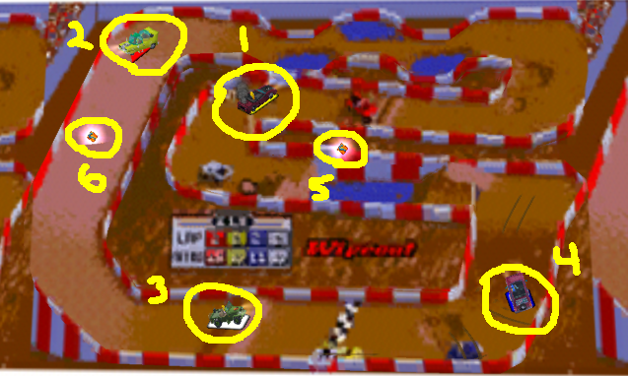

The track is a 3D track with a painted overlay. The cars as denoted by highlights 1-4 are the same 3D models as used in the main game. They have the same damage states and effects. Items 5 and 6 are examples of powerups representing Turbo and Repair. Both can be placed on the track or “in the air” as shown by #5.

The Gameplay

The first player to do 4 laps and cross the finish line wins. Pretty basic really. Points are rewarded for finishing order.

Start/Finish Line

Every track has a start line that is also the finish line. Ideally and for consistency sake, the start/finish line should be placed at the bottom of the screen on a horizontal section of track as pictured above. The four cars will start four abreast facing the direction specified from the mini racer FE (track direction can be toggled before loading level).

Track Design

Each track will be themed and based on the level in which it was awarded:

Level 1: Evergreen Terrace—School theme
Level 2: Downtown—Dog Track theme
Level 3: Seaside—Beach theme
Level 4: Evergreen Terrace--???
Level 5: Downtown-DMV theme or Stadium theme
Level 6: Seaside—Warf theme
Level 7: Halloween ET

Each track will have at least one shortcut. The shortcut will be timed based and will cycle when it is available and not available. It will be used as a form of catch-up logic.

Track Attributes

Each map may contain the following:

- Start/Finish line
- At least one shortcut
- Two way jumps (since map direction can be reversed)
- One way jumps (turn into lane barriers in the opposite direction)
- Spawn points for repair and turbo powerups
- Water hazards
- Tar hazards
- Fire hazards
- Bumps
- Ditches
- Inclines
- Hills
- Dynamic objects as obstacles
- Different terrain and friction of terrain
  - Asphalt
  - Grass
  - Gravel
  - Dirt
  - Mud

The terrain friction values will use the same system and values as the main game. The “hazards” are damage volumes and are based on the same main game system.

Powerups

- Repair
- Turbo

The repair powerup instantly fixes all car damage. The Turbo powerups the car and a special particle effect remains on the car designating that the powerup is available to be triggered. The player can strategically decide when to press the action button to use the turbo. If the player is already powered up, they will just drive through the powerup and it will remain on screen for another player to pick up. If the car damages out, if the turbo state is set, it is lost.

Damaging Out
The players cars will damage out just as in the main game minus the coin penalty.

AI Opponents

The game can be played for 1-4 players. When there are less than 4 players, the remaining player slots are filled by AI opponents. The AI will be based on the race AI from the main game.

Scoring

We will leave it to the players to decide how to judge scoring. We will track and display total races won and total points. We will sort by total races first and total points second. We will also highlight who had the best race time and best lap overall. Here is a working table for points:

1st Place: 5
2nd Place: 3
3rd Place: 2
4th Place: 1
DNF: 0

Content

- Font for countdown, text, and summary stats
- Mini game loading screen
- 7 level themed tracks (or maps) total based on the level they were awarded in.
- Front end screen for mini game
- Initial camera view per map for gameplay
- Presentation cameras for beginning of race
- Presentation cameras for end of race
- Race results screen
- Race again dialog box
- Pause menu with Continue or Quit options.
- Powerup for turbo
- Powerup for repair (wrench)
- Flags for race start, final lap, and race finish
- Placement data for powerups and AI pathing
- Race start and finish sounds

Presentation

- Title screen during mini game loading
- Countdown start of race
- Flag for race start
- Flag for final lap
- Flag for race finish
- Countdown once first player finishes for final placement of other players
- Race start fly-in showing 3D cars and characters
- Race end celebration showing winner—starts after countdown completes
- Countdown and race start sound like Pole Position(See game Final Lap in Great Room)
- Winning/Race over song rift

Front end design

There will be a total of 5 front end screens. The flow is as per mini-game flow diagram above. The layout of screens and the general designs are as follows:

<Attach scanned images>

A special note for the Race Summary screen: The order on initial showing should be the order as placed for the first race. For subsequent races where the data is not reset, show the previous ranking then change the points and adjust the people into their new positions. Once complete, show the CONTINUE button.

